**Automated Car Parking System Database Design**

1.Description :

An automated car parking system is designed to efficiently manage parking lots by utilizing advanced technologies. This system optimizes space utilization, enhances security, and provides a seamless experience for both vehicle owners and administrators. Key components include parking lots, vehicle information, parking spaces, transactions, administrators, management entities, security guards, and log records.

2. Entity-Relationship Diagram :

Automated Car Parking System

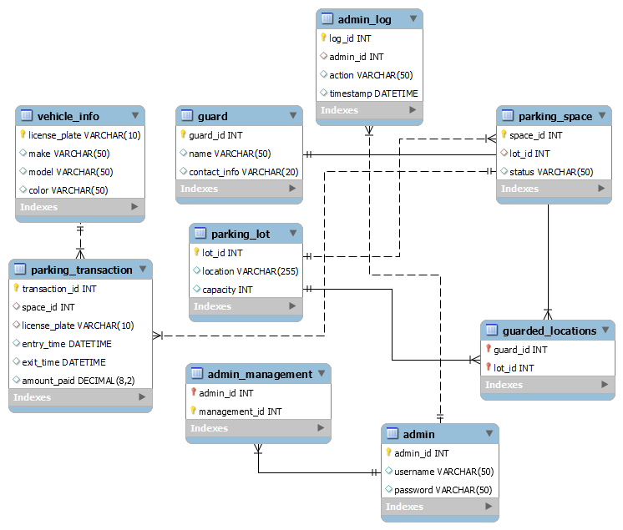

* Parking_Lot (parking_lot):
  + Attributes:
    - lot_id (Primary Key)
    - location
    - capacity
  + Relationships: None.
* Vehicle (vehicle):
  + Attributes:
    - vehicle_id (Primary Key)
    - license_plate
    - make
    - model
    - color
  + Relationships: None.
* Parking_Space (parking_space):
  + Attributes:
    - space_id (Primary Key)
    - lot_id (Foreign Key referencing parking_lot.lot_id)
    - status (occupied/available)
  + Relationships:
    - lot_id references parking_lot(lot_id).
* Parking_Transaction (parking_transaction):
  + Attributes:
    - transaction_id (Primary Key)
    - vehicle_id (Foreign Key referencing vehicle.vehicle_id)
    - space_id (Foreign Key referencing parking_space.space_id)
    - entry_time
    - exit_time
    - amount_paid
  + Relationships:
    - vehicle_id references vehicle(vehicle_id).
    - space_id references parking_space(space_id).
* Admin (admin):
  + Attributes:
    - admin_id (Primary Key)
    - username
    - password
  + Relationships: None.
* Admin_Management (admin_management):
  + Attributes:
    - admin_id (Foreign Key referencing admin.admin_id)
    - management_id (Foreign Key referencing management.management_id)
  + Relationships: None.
* Guard (guard):
  + Attributes:
    - guard_id (Primary Key)
    - name
    - contact_info
  + Relationships: None.
* Guarded_Locations (guarded_locations):
  + Attributes:
    - guard_id (Foreign Key referencing guard.guard_id)
    - lot_id (Foreign Key referencing parking_lot.lot_id)
  + Relationships: None.
* Admin_Log (admin_log):
  + Attributes:
    - log_id (Primary Key)
    - admin_id (Foreign Key referencing admin.admin_id)
    - action
    - timestamp
  + Relationships: None.

3. Table Details:

* Parking Lot Table (parking_lot):
  + Attributes:
    - lot_id (Primary Key, INT)
    - location (VARCHAR)
    - capacity (INT)
* Vehicle Table (vehicle):
  + Attributes:
    - vehicle_id (Primary Key, INT)
    - license_plate (VARCHAR)
    - make (VARCHAR)
    - model (VARCHAR)
    - color (VARCHAR)
* Parking Space Table (parking_space):
  + Attributes:
    - space_id (Primary Key, INT)
    - lot_id (Foreign Key, INT)
    - status (ENUM: occupied/available)
* Parking Transaction Table (parking_transaction):
  + Attributes:
    - transaction_id (Primary Key, INT)
    - vehicle_id (Foreign Key, INT)
    - space_id (Foreign Key, INT)
    - entry_time (DATETIME)
    - exit_time (DATETIME)
    - amount_paid (DECIMAL)
* Admin Table (admin):
  + Attributes:
    - admin_id (Primary Key, INT)
    - username (VARCHAR)
    - password (VARCHAR)
* Admin_Management Table (admin_management):
  + Attributes:
    - admin_id (Foreign Key, INT)
    - management_id (Foreign Key, INT)
* Guard Table (guard):
  + Attributes:
    - guard_id (Primary Key, INT)
    - name (VARCHAR)
    - contact_info (VARCHAR)
* Guarded_Locations Table (guarded_locations):
  + Attributes:
    - guard_id (Foreign Key, INT)
    - lot_id (Foreign Key, INT)
* Admin_Log Table (admin_log):
  + Attributes:
    - log_id (Primary Key, INT)
    - admin_id (Foreign Key, INT)
    - action (VARCHAR)
    - timestamp (DATETIME)

4. Normalization Process:

Unnormalized tables:

Parking_Lot_Info:

| **lot_id** | **location** | **capacity** | **license_plate** | **make** | **model** | **color** |
| --- | --- | --- | --- | --- | --- | --- |
| 1 | 'Main Street Garage' | 300 | 'ABC123' | 'Toyota' | 'Camry' | 'Red' |
| 2 | 'City Center Parking' | 200 | 'XYZ789' | 'Honda' | 'Civic' | 'Blue' |
| 3 | 'Tech Hub Parking' | 150 | 'DEF456' | 'Ford' | 'Focus' | 'Silver' |
| 4 | 'Downtown Parking Plaza' | 400 | 'GHI789' | 'Chevrolet' | 'Malibu' | 'Black' |
| 5 | 'Suburban Park and Ride' | 250 | 'JKL012' | 'Tesla' | 'Model 3' | 'White' |

Parking_Transaction:

| **space_id** | **status** | **entry_time** | **exit_time** | **amount_paid** |
| --- | --- | --- | --- | --- |
| 111 | 'occupied' | '2023-12-14 09:00:00' | '2023-12-14 12:30:00' | 15.50 |
| 333 | 'available' | '2023-12-14 10:15:00' | '2023-12-14 13:45:00' | 20.00 |
| 222 | 'available' | '2023-12-14 11:30:00' | '2023-12-14 14:00:00' | 18.75 |
| 444 | 'available' | '2023-12-14 13:00:00' | '2023-12-14 16:30:00' | 22.50 |
| 555 | 'occupied' | '2023-12-14 14:45:00' | '2023-12-14 17:15:00' | 25.00 |

Admin_guard_details:

| admin_id | username | password | management_id | Admin_ management_id | guard_id | Contact_info |
| --- | --- | --- | --- | --- | --- | --- |
| 123 | 'admin1' | 'pass1' | M253 | AD2536 | G235 | 'Guard1' |
| 344 | 'admin2' | 'pass2' | M567 | AD2563 | G356 | 'Guard2' |

| Guarded_Location_id | log_id | action | timestamp |
| --- | --- | --- | --- |
| LOC14 | L25 | 'Login' | '2023-12-14 08:30:00' |
| LOC34 | L29 | 'Logout' | '2023-12-14 12:45:00' |

* Check for First Normal Form (1NF):

The table is already in 1NF, as there are no repeating groups, and each cell contains a single value.

* Check for 2nd Normal Form (2NF)

Removing partial dependencies.

In the unnormalized state, the attributes location,capacity depend both on lot_id and space_id.So create a separate table called parking_lot.

parking_lot:

| **lot_id** | **location** | **capacity** |
| --- | --- | --- |
| 1 | 'Main Street Garage' | 300 |
| 2 | 'City Center Parking' | 200 |
| 3 | 'Tech Hub Parking' | 150 |
| 4 | 'Downtown Parking Plaza' | 400 |
| 5 | 'Suburban Park and Ride' | 250 |

Create a separate table called vehicles with vehicle_id as primary key.

Vehicle:

| **vehicle_id** | **license_plate** | **make** | **model** | **color** |
| --- | --- | --- | --- | --- |
| 101 | 'ABC123' | 'Toyota' | 'Camry' | 'Red' |
| 102 | 'XYZ789' | 'Honda' | 'Civic' | 'Blue' |
| 103 | 'DEF456' | 'Ford' | 'Focus' | 'Silver' |
| 104 | 'GHI789' | 'Chevrolet' | 'Malibu' | 'Black' |
| 105 | 'JKL012' | 'Tesla' | 'Model 3' | 'White' |

Parking_transaction:

| **transaction_id** | **space_id** | **status** | **entry_time** | **exit_time** | **amount_paid** |
| --- | --- | --- | --- | --- | --- |
| 100 | 111 | 'occupied' | '2023-12-14 09:00:00' | '2023-12-14 12:30:00' | 15.50 |
| 200 | 333 | 'available' | '2023-12-14 10:15:00' | '2023-12-14 13:45:00' | 20.00 |
| 300 | 222 | 'available' | '2023-12-14 11:30:00' | '2023-12-14 14:00:00' | 18.75 |
| 400 | 444 | 'available' | '2023-12-14 13:00:00' | '2023-12-14 16:30:00' | 22.50 |
| 500 | 555 | 'occupied' | '2023-12-14 14:45:00' | '2023-12-14 17:15:00' | 25.00 |

Check for 3rd Normal Form (3NF)

Removing transitive dependency.

There is a transitive dependency between space_id ,status and amount_paid in the parking_transactions table.

Parking_space:

| **lot_id** | **space_id** | **status** |
| --- | --- | --- |
| 1 | 111 | 'occupied' |
| 2 | 333 | 'available' |
| 3 | 222 | 'available' |
| 4 | 444 | 'available' |
| 5 | 555 | 'occupied' |

Parking_transaction:

| **transaction_id** | **space_id** | **vehicle_id** | **entry_time** | **exit_time** | **amount_paid** |
| --- | --- | --- | --- | --- | --- |
| 100 | 111 | 101 | '2023-12-14 09:00:00' | '2023-12-14 12:30:00' | 15.50 |
| 200 | 333 | 102 | '2023-12-14 10:15:00' | '2023-12-14 13:45:00' | 20.00 |
| 300 | 222 | 103 | '2023-12-14 11:30:00' | '2023-12-14 14:00:00' | 18.75 |
| 400 | 444 | 104 | '2023-12-14 13:00:00' | '2023-12-14 16:30:00' | 22.50 |
| 500 | 555 | 105 | '2023-12-14 14:45:00' | '2023-12-14 17:15:00' | 25.00 |

parking_lot:

| **lot_id** | **location** | **capacity** |
| --- | --- | --- |
| 1 | 'Main Street Garage' | 300 |
| 2 | 'City Center Parking' | 200 |
| 3 | 'Tech Hub Parking' | 150 |
| 4 | 'Downtown Parking Plaza' | 400 |
| 5 | 'Suburban Park and Ride' | 250 |

Vehicle:

| **vehicle_id** | **license_plate** | **make** | **model** | **color** |
| --- | --- | --- | --- | --- |
| 101 | 'ABC123' | 'Toyota' | 'Camry' | 'Red' |
| 102 | 'XYZ789' | 'Honda' | 'Civic' | 'Blue' |
| 103 | 'DEF456' | 'Ford' | 'Focus' | 'Silver' |
| 104 | 'GHI789' | 'Chevrolet' | 'Malibu' | 'Black' |
| 105 | 'JKL012' | 'Tesla' | 'Model 3' | 'White' |

Create a separate table for the Admin

Admin:

| **admin_id** | **username** | **password** |
| --- | --- | --- |
| 123 | 'admin1' | 'pass1' |
| 344 | 'admin2' | 'pass2' |

Admin_Management Table:

| **admin_id** | **management_id** |
| --- | --- |
| 123 | M253 |
| 344 | M567 |

Guard Table:

| **guard_id** | **name** | **contact_info** |
| --- | --- | --- |
| G235 | 'Guard1' | '123-456-7890' |
| G356 | 'Guard2' | '987-654-3210' |

Guarded_Locations Table:

| **guard_id** | **lot_id** |
| --- | --- |
| G235 | 1 |
| G356 | 2 |

Admin_Log Table:

| **log_id** | **admin_id** | **action** | **timestamp** |
| --- | --- | --- | --- |
| L25 | 123 | 'Login' | '2023-12-14 08:30:00' |
| L29 | 344 | 'Logout' | '2023-12-14 12:45:00' |